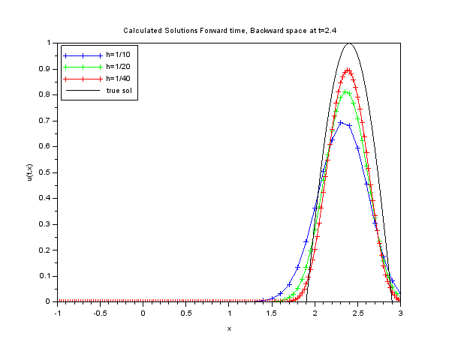



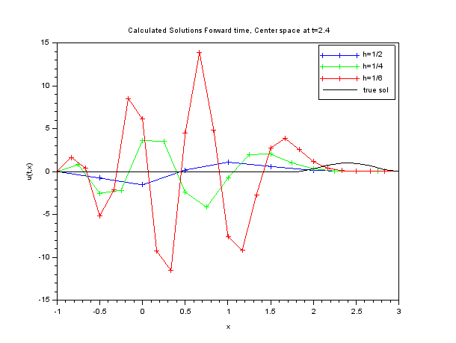

The scheme for lambda=.8 starts to blow up when h=1/6. In no version does is give a useful approximation to the true solution. The results from Lax-Friedrichs lambda=1.6 leads one to speculate that a better lambda might exist so this scheme would be useful.

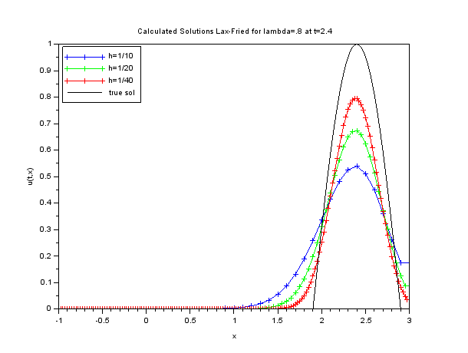

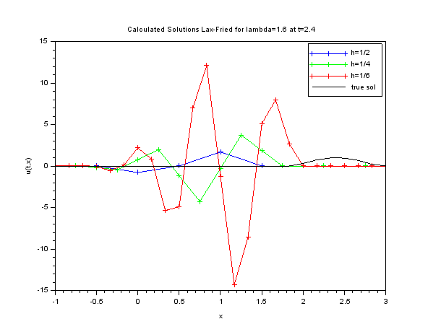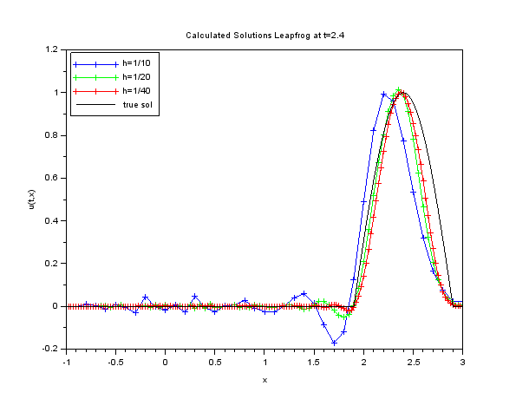

The scheme for lambda=1.6 starts to blow up when h=1/6. In no version does is give a useful approximation to the true solution. It is interesting to note that for lambda=.8 the scheme is very useful. However just changing the ratio of space/time spacing can completely change the usefulness of a scheme.